Court, Terry J (based mainly on Roger Underwood (2006) “Old Growth Foresters. The lives and times of West Australian Foresters”)
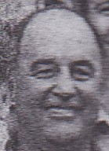
Terry Court (son of Les Court) worked in a Forests Department gang in Pemberton in 1960. He graduated from the Dwellingup Cadet School in 1964. Briefly worked as a chainman for Working Plans Office. Forest Guard in Shannon River/Walpole, transferred to Pemberton 15.8.1968. He worked in Pemberton district (1968-90s), during a career of 25 years with the Forests Department. Promoted to Assistant Forester at Quininup in 1972 and later to Forester in Walpole. Senior Forester at Pemberton in 1988. Worked for the CALM Regional Office, then Forest Products Commission in Manjimup, for about 15 years. Retired after 40 years service in mid 2000s.

